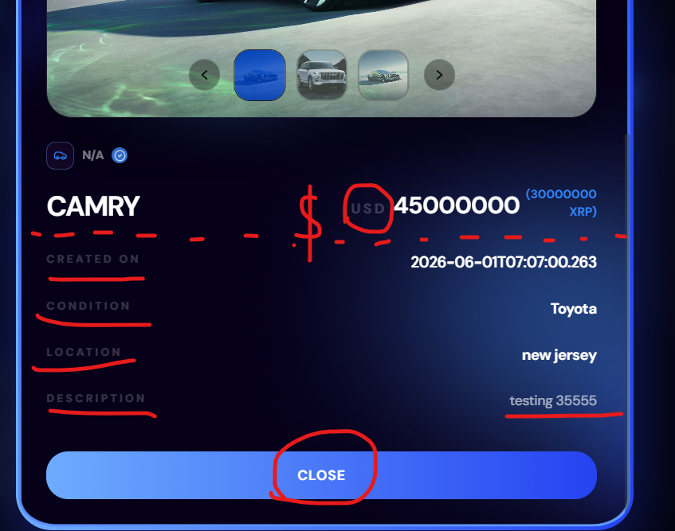
Text color issue and close button should not be wide in size
and below name ---------- line missing
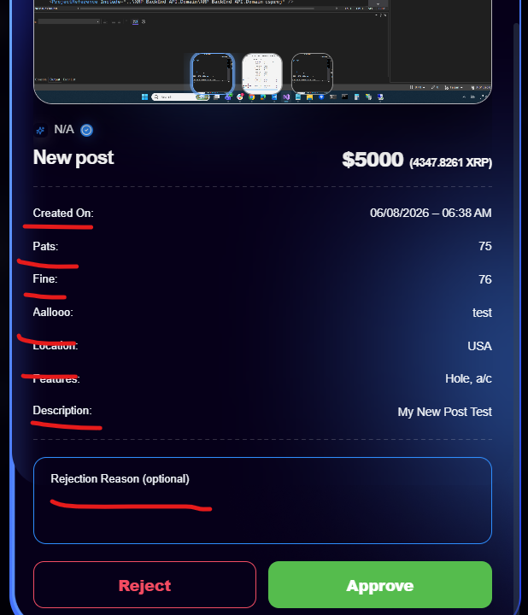
Should be dim in color

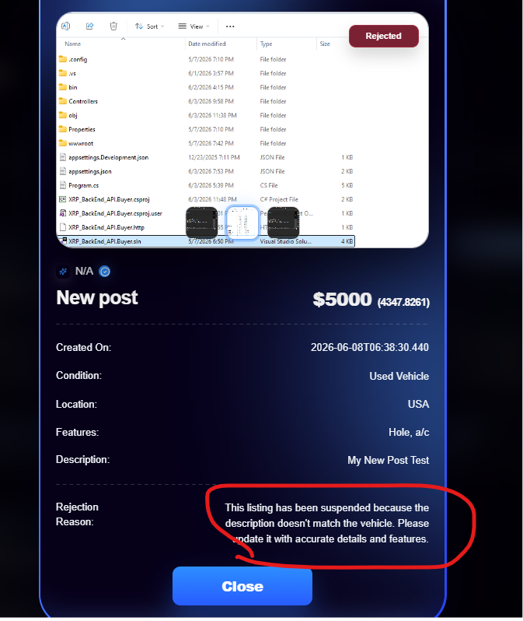
I didn’t write any rejection reason when rejecting the list but it shows when admin view

